| **TEST_PLAN**  Project Name : Write Wave  URL Link :https://write-wave-gamma.vercel.app/ |
| --- |

| **Prepared By**: Anil Rajak    **Start Date:** 13-03- 2025    **End Date:**,13-03 2025 |
| --- |

| **Table of Content** |
| --- |

● Introduction

● Objectives

● Scope

● Testable Features

● Testing Approach

● Roles/Responsibilities

● Test Schedule

● Test Deliverables

● Entry & Exit Criteria

● Tools

● Risks and Mitigation Plans

● Approvals

| **Introduction** |
| --- |

This document outlines the testing strategies and scope for the **Write Wave**. Testing ensures proper functionality, UI/UX, compatibility, and performance for key features such as registration, login, Home page,search bar.

● Website Link: <https://write-wave-gamma.vercel.app/>

| **Objectives** |
| --- |

● Ensure all navigation links and features work as intended.

● Verify functionality of critical features (Registration, Login, Home page,Profile, Start writing, personal stories,Creative write,Travel blogs, Tech Insights,search, etc.).

● Ensure responsiveness across browsers and devices.

● Validate Manual Test scenarios implemented Test Cases

| **Scope** |
| --- |

The test plan covers **functional, UI/UX,** and **Usability** testing across major browsers (Chrome,Firefox,Edge) and devices (mobile). It includes manual testing of core features to ensure user experience consistency and reliability and manual testing performed for Non-functional testing.

| **Testable Features** |
| --- |

● **Registration & Login**: Creating accounts and authenticating users.

● **Featured Categories:,** tested the Personal Stories, Creative writing , Travel blogs , tech insights, Motivational thoughts , Food & Recipes .

* **Start Writing :** Crediting the post and title summary upload documents .
* **Quick links : The tested**  Home , About , contact , Privacy .
* **Footer Links**: Testing links like Your account , return central and Help .
* **Responsive Design**: Verifying UI elements on different screen sizes and devices.

| **Testing Approach** |
| --- |

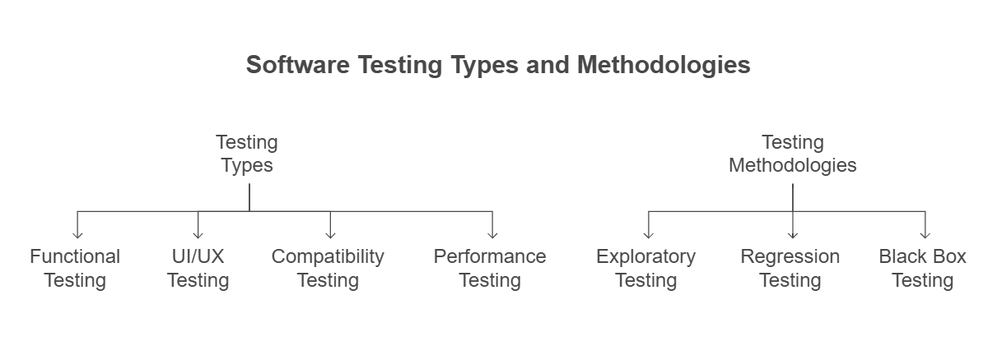

**Testing Types**:

● **Functional Testing**: Verify that features (e.g., registration) perform as expected.

● **UI/UX Testing**: Ensure the website is visually appealing, intuitive, and user-friendly.

● **Compatibility Testing**: Test across devices (Browser, tablet, mobile).

● **Performance Testing**: Measure page load times and responsiveness for critical features.

**Testing Methodologies:**

● **Exploratory Testing:** Testing beyond documented scenarios.

● **Regression Testing:** Validating existing features after bug fixes or new feature additions.

● **Black Box Testing:** Testing without knowledge of internal implementation.

| **Roles/Responsibilities** |
| --- |

As the sole tester for this project, I was responsible for:

● Creating a comprehensive **Test Plan** to outline objectives, scope, and strategies.

● Manual test cases approach.

● Conducting manual and exploratory testing to ensure functional, UI/UX, and compatibility quality.

● Identifying and analysing bugs through thorough testing and documenting insights.

● Compiling a **Test Results Summary** to highlight testing outcomes and application quality.

| **Test Schedule** |
| --- |

| **Task** | **Duration** |
| --- | --- |
| Test Plan Creation & Mind Map | 13 March 2025 |
| Test Scenario | 13 March 2025 |
| Test Scripts & Execution | 13 March 2025 |
| Manual Test cases & Bug Reporting | 13 March 2025 |
| Test Summary / Presentation Report Submission | 13 March 2025 |

| **Test Deliverables** |
| --- |

| **Deliverable** | **Description** |
| --- | --- |
| RTM | Detailed Requirement strategy and Feature. |
| Mind Map & Test Plan | Detailed testing strategy and scope |
| Manual Test Cases | Detailed cases for functional/UI testing |
| Defect Reports | Identified bugs during testing |
| Test Summary | Detail summarise what you have done in whole Testing |

| **Entry & Exit Criteria** |
| --- |

**Entry Criteria**:

● Access to the Write Wave website.

● All features available and functional.

● Approved scenarios and manual scripts ready for execution.

**Exit Criteria**:

● All critical and high-priority bugs fixed.

● All features meet the expected behaviour defined in scenarios.

| **Tools** |
| --- |

1. **BrowserStack**: For cross-browser and device compatibility testing.

2. **Google Sheet**: For Manual Testing to be non-functional.

3. **Google Docs**: For creating Test Plan and Test Summary.

| **Risks and Mitigation Plans** |
| --- |

| **Deliverable** | **Description** |
| --- | --- |
| Unstable website | Plan testing during stable hours. |
| Undefined requirements | Clarify requirements before testing. |

| **Approvals** |
| --- |

